ACTIVITY :- 1
- HTML CODE :-
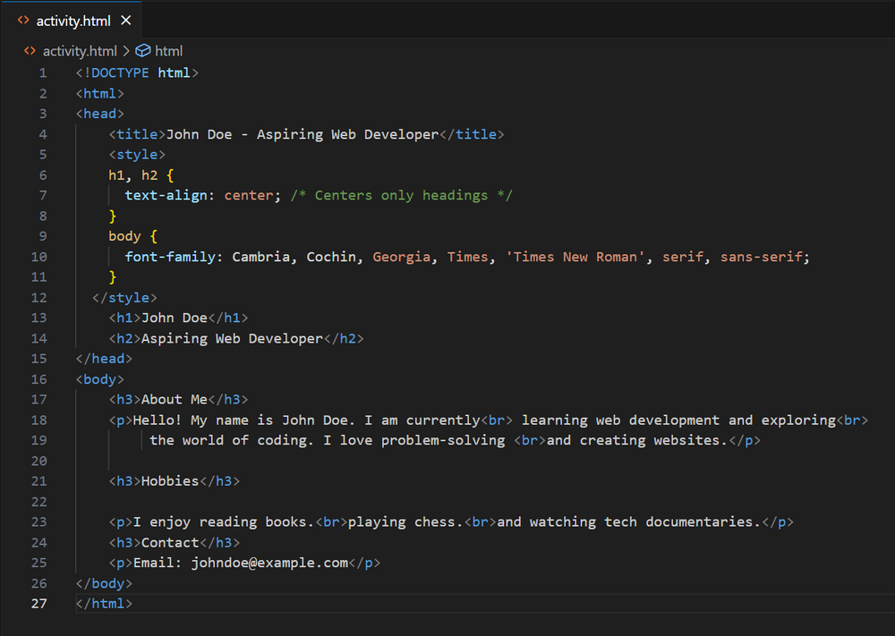
- OUTPUT :-
